Center for Medical Humanities, Compassionate Care, and Bioethics.
Stony Brook University Health Sciences Center

33nd Annual History of Medicine Lecture Series
http://www.sunysb.edu/bioethics/historyofmedicine.shtml

"Gender, History, and the Process of Forgetting:
The Case of Sister Kenny"

Naomi Rogers, PhD, Yale University
Associate Professor of History of Medicine & Women's and Gender Studies

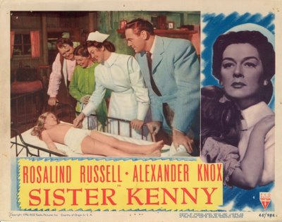

Biography: Naomi Rogers received her PhD in the History & Sociology of Science at the University of Pennsylvania. Her first book, Dirt and Disease: Polio before FDR, was published by Rutgers University Press in 1992 and her second book, An Alternative Path: the Making and Remaking of Hahnemann Medical College and Hospital of Philadelphia, was published by Rutgers University Press in 1998. Her current work is part of a manuscript she is completing, tentatively titled, Healer from the Outback: Sister Elizabeth Kenny, Polio and American Medicine, 1940-1952.
Tuesday, March 9th, 2010
Wang Center, Lecture Hall 2
4:00 pm

