Stony Brook University Medical Center, 35nd Annual History of Medicine Lecture Series
"From Medical Eugenics to Genomic Medicine: The Relief of Suffering and the Self-Direction of Human Evolution."
Nathaniel Comfort, PhD, Johns Hopkins University, Institute for the History of Medicine
Contemporary genetic medicine is both revolutionary and deeply traditional. Our mastery of the molecules of life is unprecedented—yet modern medical genomics shares some of the same basic goals with the eugenicists and geneticists of the early 20th century. The historian of medicine Nathaniel Comfort examines how genetics became medical—and how medicine became genetic.
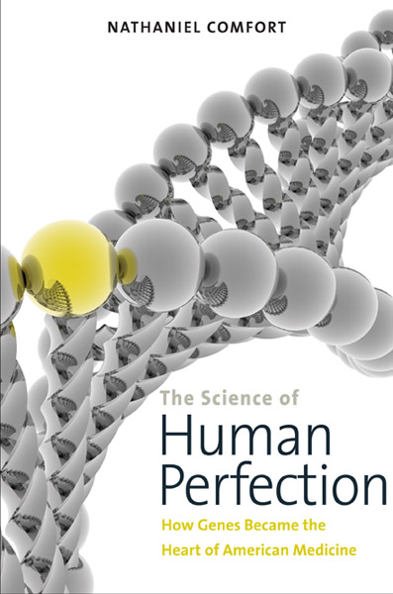
Dr. Nathaniel Comfort received his PhD from Stony Brook University for work on the development of Barbara McClintock’s understanding of transposons and other forms of mobile DNA. This work was published as The Tangled Field: Barbara McClintock's Search for the Patterns of Genetic Control (Cambridge, MA: Harvard University Press, 2001). His most recent book, The Science of Human Perfection: How Genes Became the Heart of American Medicine was published by Yale University Press in September 2012. Comfort’s work centers on heredity and health in 20th century America. His newest book examines the growth and evolution of medical genetics from the early days of Mendelism to the Human Genome Project.
Sponsored by the Center for Medical Humanities, Compassionate Care & Bioethics, School of Medicine and the Department of History, College of Arts & Sciences

